Pennsylvania Organisms Research
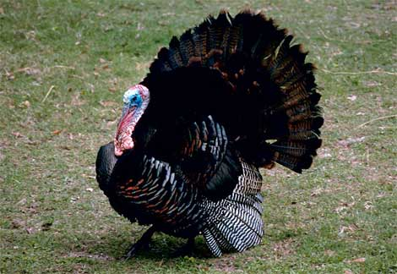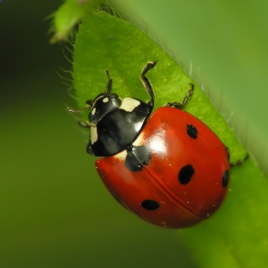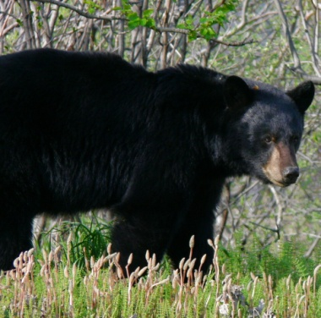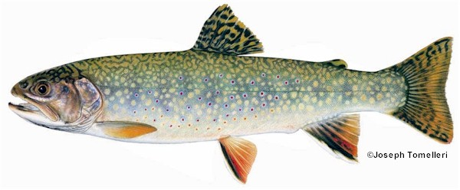

Choose an organism which is native to Pennsylvania. You may choose a plant, animal, fungus, or protist. Use web resources to collect information about the organism. Be sure to document your source.

- Find the Genus and species name.
- Provide a detailed description of the organism; size, colors, type of respiration, type of circulation, specific structures.
- Describe the organism’s habitat and range. Where does it live?
- Describe any behaviors that are displayed by the organism.
- Describe how it reproduces.
- Describe it’s life cycle.
- Provide two photos or diagrams of the organism. Be sure to include a caption, and credit of your source for your photos.
- Provide the classification of the organism: Kingdom, phylum, class, order, family, genus, species.

